School of Informatics & IT

Diploma in Cybersecurity and Digital Forensics

CDF3C01 – Incident Response and Management (ICRM)

Lab 3 – Security Incident Response Management I

Learning Outcomes
By the end of this practical lesson, the student should be able to demonstrate the following items:
- Identify running processes and its network characteristics on both Windows and Linux machines.
- Parse server logs using readily available Linux applications to present data in a readable format.

Tasks

Background / Scenario
Processes are programs or applications that are currently in execution on the host machine. In the event of troubleshooting application faults, logs are configured by default to take note of all errors and transactions that have occurred between the application server and the corresponding client. This is quite useful as a security analyst is required to gather evidence to prove his/her theory of a possible security breach that has happened within the organisation.

Windows Systems

Identify Running Processes

Step 1: Windows VM Configuration
- Under the ‘Network’ configuration, ensure that the adapter is set to NAT for the WIN7-LAB VM.
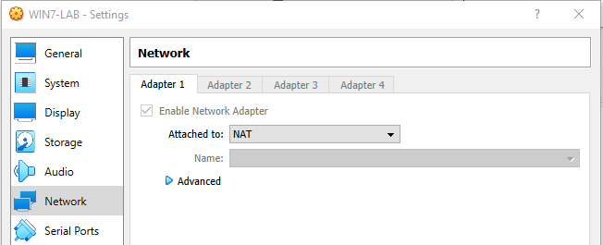
- Log into the Windows machine with the following user credentials:
- Username: OfficeUser
- Password: benfica

Step 2: Start TCP/UDP Endpoint Viewer
- Navigate to the SysInternalsSuite folder that is located on the Windows Desktop.
- Open Tcpview.exe. Accept the Process Explorer License Agreement when prompted. Click Yes to allow this app to make changes to your device.

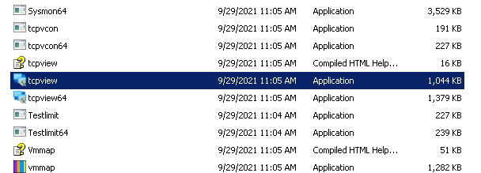
- Exit the File Explorer and close all the currently running applications.

Step 3: Explore a running system process
- TCPView lists the processes that are currently running on your Windows machine. Currently, only Windows processes are running in the system:
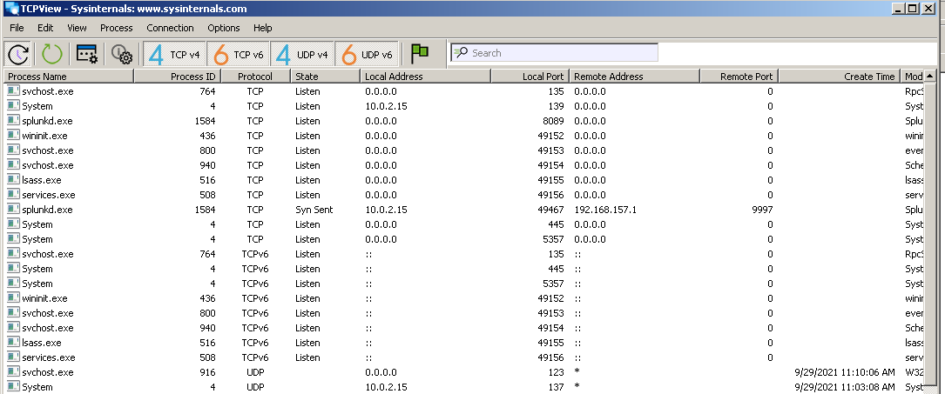
- Double-click on the ‘lsass.exe’ process and fill up the following information:
Executable file name

Location of executable

Name of Windows service tied to the executable

Description of executable (what does it do)

- Close the properties window for lsass.exe when done.

Step 4: Explore a user-initiated process.
- Launch the Internet Explorer web browser on the Windows machine while keeping the TCPView window open. What did you observe?

- Fill up the following table below regarding the Internet Explorer web browser:
Process Name

Location of executable

Process ID (PID)

Remote Ports and Port Type
(e.g TCP/UDP <port number>)

- Notice that upon launching the web browser, it loads the default home page (https://www.msn.com), but there are multiple connections being loaded from the Internet Explorer process. Why is that so?

2.2.2 Exploring Processes, Threads, and Windows Registry

Step 1: Explore an active process.
- Ensure that you still have the Internet Explorer web browser launched in the background.
- Navigate to the SysInternalsSuite folder with all the extracted files.
- Open procexp.exe and accept the Process Explorer License Agreement when prompted.
- The Process Explorer displays a list of currently active processes.
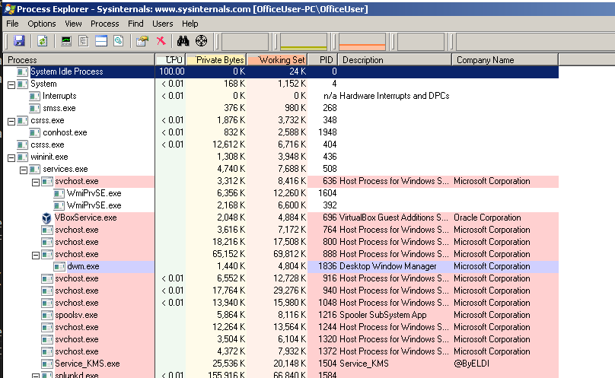
- To locate the web browser process, drag the Find Window's Process icon () into the opened web browser window.
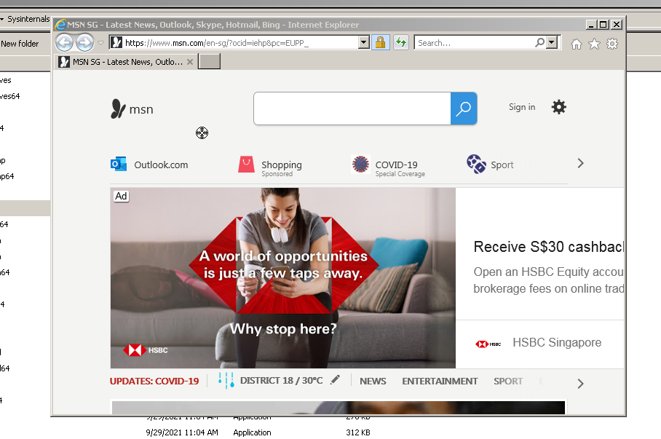
- Right-click on the selected process and select Kill Process
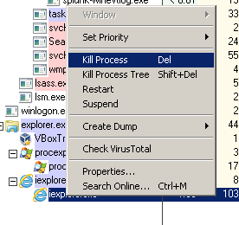
- What happened to the web browser window when the process is killed?

Step 2: Explore an active process.
      - Open a Command Prompt. (Start > search Command Prompt > select Command Prompt)
      - Drag the Find Window's Process icon () into the Command Prompt window and locate the highlighted Command Prompt process in Process Explorer.
      - The process for the Command Prompt is cmd.exe. Its parent process is explorer.exe process. The cmd.exe has a child process, conhost.exe.
      - Navigate to the Command Prompt window and run the following command:
ping 8.8.8.8
      - What happened during the ping process?

Step 3: Explore threads.
- Open a Command Prompt. (Start > search Command Prompt > select Command Prompt).
- In Process Explorer window, right-click conhsot.exe and Select Properties…. Click the Threads tab to view the active threads for the conhost.exe process.
- Fill up the following table below:
TID | Start Address

- What is a DLL file? Why is it important for security analysts to understand how DLL files work in the context of running processes?

Step 4: Exploring Windows Registry
The Windows Registry is a hierarchical database that stores most of the operating systems and desktop environment configuration settings:
- To access the Windows Registry, click Start > Search for regedit and select Registry Editor. Click Yes when asked to allow this app to make changes.
- The Registry Editor has five hives. These hives are at the top level of the registry.
  - HKEY_CLASSES_ROOT is the Classes subkey of HKEY_LOCAL_MACHINE\Software\. It stores information used by registered applications like file extension association, as well as a programmatic identifier (ProgID), Class ID (CLSID), and Interface ID (IID) data.
  - HKEY_CURRENT_USER contains the settings and configurations for the users who are currently logged in.
  - HKEY_LOCAL_MACHINE stores configuration information specific to the local computer.
  - HKEY_USERS contains the settings and configurations for all the users on the local computer. HKEY_CURRENT_USER is a subkey of HKEY_USERS.
  - HKEY_CURRENT_CONFIG stores the hardware information that is used at bootup by the local computer.
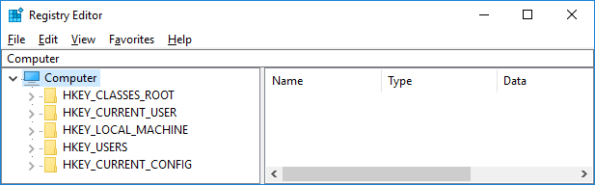

- In a previous step, you had accepted the EULA for Process Explorer. Navigate to the EulaAccepted registry key for Process Explorer.
Click to select Process Explorer in HKEY_CURRENT_USER > Software > Sysinternals > Process Explorer. Scroll down to locate the key EulaAccepted. Currently, the value for the registry key EulaAccepted is 0x00000001(1).
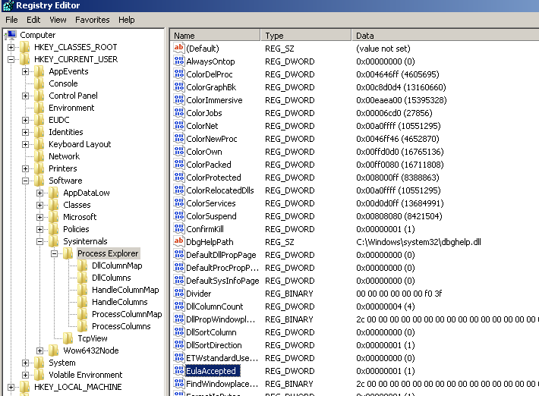
- Double-click EulaAccepted registry key. Currently the value data is set to 1. The value of 1 indicates that the EULA has been accepted by the user.
- Change the 1 to 0 for Value data, and once changed launch the Process Explorer. What happens now?

    - Malware Challenge
In the Windows system there are 3 executables that require further investigation. Details of the executables will be listed in the table below, and your task is to fill up the blanks to obtain further information regarding the executables:
Executable 1 (run the application to obtain the information needed)
File Location | C:\Users\OfficeUser\Downloads\Lab3_Challenge1.exe
Process Name
(if there is a child process, specify both parent and child process name)
Process ID
(if there is a child process, specify both parent and child process ID)
Network connections?
(if yes, specify the remote IP address and the remote port used)
File Description
(How was it created? What does it do?)

Executable 2 (run the application to obtain the information needed)
File Location | C:\Users\OfficeUser\Downloads\Lab3_Challenge2.exe
Process Name
(if there is a child process, specify both parent and child process name)
Process ID
(if there is a child process, specify both parent and child process ID)
Network connections?
(if yes, specify the remote IP address and the remote port used)
File Description
(How was it created? What does it do?)

Executable 3
File Location
Process Name
(if there is a child process, specify both parent and child process name)
Process ID
(if there is a child process, specify both parent and child process ID)
Network connections?
(if yes, specify the remote IP address and the remote port used)
File Description  (How was it created? What does it do?) | Executable 3 was created using the “persistence_exe” Metasploit module. Refer to this article for more info: https://www.hackingarticles.in/multiple-ways-to-persistence-on-windows-10-with-metasploit/

Linux Systems

2.3.1 Exploring Processes and Network Connections
Identifying the process ID and the network connections are relatively similar in Linux, and this is much simpler as it requires usage of two Linux binaries:
- netstat – shows list of network connections made by the system
- ps – shows the list of processes running on the system

      - Boot the ICRM-CENTOS8 Linux VM, and login with the following credentials (you will need to click ‘Log in as another user’:
- Username: root
- Password: enjoyit123
      - Type the following commands on the Linux console:
        - netstat -anop | grep tcp
        - ps -aux

      - Find out the significance of each part of the command syntax based on the commands above:
1 | 2 | 3 | 4 | 5
netstat | -anop | | | grep | tcp

6 | 7
ps | -aux

No. | Description
1
2
3
4
5
6
7
      - Run the following Linux commands on the server (in the following order), and fill up the table below using both netstat and ps:
- nc -nlvp 8888 &
- nc localhost 8888 &
Linux Executable
File location
Process Name
(if there is a child process, specify both parent and child process name)
Process ID
(if there is a child process, specify both parent and child process ID)
Network connections?
(if yes, specify the remote IP address and the remote port used)
File Description
(How was it created? What does it do?)

2.3.2 Reading Server Logs
Log files are files used to record specific events triggered by applications, services, or the operating system itself. Usually stored as plain-text, log files are an indispensable resource for troubleshooting. Log files commonly contain plain-text information which can be viewed by practically any program able to handle text (text editors, for example). However, because of convenience, usability, and speed, a few tools are more commonly used than others. This section focuses on four command-line-based programs: cat, more, less, and tail.

Step 1: Using the ‘cat’ tool
- Boot the ICRM-CENTOS8 Linux VM, and login with the following credentials:
- Username: root
- Password: enjoyit123
- On the Linux console, issue the command below to display the contents of the logstash-tutorial.log file:
dmz@dmzhost ~$ cat ~/logstash-tutorial.log
- The contents of the file should scroll through the terminal window until all contents have been displayed.

Step 2: Using the ‘more’ tool
Another popular tool for visualizing log files is more. Like cat, more is also a UNIX command-line-based tool that can open a text-based file and display the file contents on the screen. The main difference between cat and more is that more supports page breaks, allowing the user to view the contents of a file, one page at a time. This can be done using the space bar to display the next page.
- From the same terminal window, use the command below to display the contents of the logstash-tutorial.log file again. This time using more:
dmz@dmzhost ~$ more ~/logstash-tutorial.log
The contents of the file should scroll through the terminal window and stop when one page is displayed. Press the space bar to advance to the next page. Press Enter to display the next line of text.

Step 3: Using the ‘less’ tool
Building on the functionality of cat and more, the less tool allows the contents of a file to be displayed page by page, while also allowing the user the choice of viewing previously displayed pages.
- From the same terminal window, use the command below to display the contents of the logstash-tutorial.log file again. This time using less:
dmz@dmzhost ~$ less ~/logstash-tutorial.log
- The contents of the file should scroll through the terminal window and stop when one page is displayed. Press the space bar to advance to the next page. Press Enter to display the next line of text. Use the up and down arrow keys to move back and forth through the text file.
- Use the “q” key on your keyboard to exit the less tool.
- The tail command displays the end of a text file. By default, tail displays the last ten lines of the file. Use tail to display the last ten lines of the logstash-tutorial.log file.
dmz@dmzhost ~$ tail ~/logstash-tutorial.log
- Based on the usages of more, less, cat and tail, list out the pros and cons of using each tool using the table below:
Linux Tool | Pros | Cons
cat
more
less
tail

2.3.3 Normalized Timestamps in a Log File
Timestamps are used in log entries to specify when the recorded event took place. While it is best practice to record timestamps in UTC, the format of the timestamp varies from log source to log source. There are two common timestamp formats, known as Unix Epoch and Human Readable.
Unix Epoch timestamps record time by measuring the number of seconds that have passed since January 1st 1970. Human Readable timestamps record time by representing separate values for year, month, day, hour, minute, and second.
The Human Readable Wed, 28 Jun 2017 13:27:18 GMT timestamp is the same as 1498656439 in Unix Epoch.
From a programmability standpoint, it is much easier to work with Epoch as it allows for easier addition and subtraction operations. From an analysis perspective, however, Human Readable timestamps are much easier to interpret.

Step 1: Using the ‘awk’ tool
Assume that a log analyst needed to convert the timestamps to the Human Readable format for the log file applicationX_in_epoch.log, follow the steps below:
- Issue out the following Linux command to convert and print the result on the terminal using the ‘awk’ tool:
dmz@dmzhost:~/ awk 'BEGIN {FS=OFS="|"}{$3=strftime("%c",$3)} {print}' ~/applicationX_in_epoch.log
The main structure of the AWK script is as follows:
- awk – This invokes the AWK interpreter.
- ‘BEGIN – This defines the beginning of the script.
- {} – This defines actions to be taken in each line of the input text file. An AWK script can have several actions.
- FS = OFS = “|” – This defines the field separator (i.e., delimiter) as the bar (|) symbol. Different text files may use different delimiting characters to separate fields. This operator allows the user to define what character is used as the field separator in the current text file.
- $3 – This refers to the value in the third column of the current line. In the applicationX_in_epoch.log, the third column contains the timestamp in epoch to be converted.
- strftime - This is an AWK internal function designed to work with time. The %c and $3 in between parenthesis are the parameters passed to strftime.
- ~/applicationX_in_epoch.log – This is the path to the input text file to be loaded and used.
The first script action, defined in the first set of curly brackets is to define the field separator character as the “|”. Then, in the second set of curly brackets, it rewrites the third column of each line with the result of the execution of the strftime() function. strftime() is an internal AWK function created to handle time conversion. Notice that the script tells the function to use the contents of the third column of each line before the change ($3) and to format the output (%c).

Were the Unix Epoch timestamps converted to Human Readable format? Were the other fields modified? Explain.
Compare the contents of the file and the printed output. Why is there the line, ||Wed 31 Dec 1969 07:00:00 PM EST?
Use nano (or your favorite text editor) to remove the extra empty line at the end of the file and run the AWK script again. Is the output correct now? Explain.

Step 2: Refining the ‘awk’ command tool

- While printing the result on the screen is useful for troubleshooting the script, analysts will likely need to save the output in a text file. Redirect the output of the script above to a file named applicationX_in_human.log to save it to a file:
[analyst@secOps lab.support.files]$ awk 'BEGIN {FS=OFS="|"}{$3=strftime("%c",$3)} {print}' ~/applicationX_in_epoch.log > ~/applicationX_in_human.log

What was printed by the command above? Is this expected?
- Use cat to view the applicationX_in_human.log. Notice that the extra line is now removed and the timestamps for the log entries have been converted to human readable format.

2.3.4 Parsing Challenge – Apache Log File
Like what was done with the applicationX_in_epoch.log file, Apache log files can also be normalized. Follow the steps below to convert Unix Epoch to Human Readable timestamps. Consider the following Apache log file, apache_in_epoch.log:
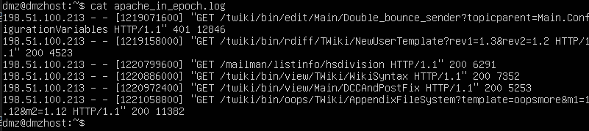
The Apache Log file above contains six entries which record events related to the Apache web server. Each entry has seven fields. The fields are delimited by a space:
- The first column contains the IPv4 address, 198.51.100.213, of the web client placing the request.
- The second and third columns are not used and a “-“character is used to represent no value.
- The fourth column contains the timestamp in Unix Epoch time, for example [1219071600].
- The fifth column contains text with details about the event, including URLs and web request parameters. All six entries are HTTP GET messages. Because these messages include spaces, the entire field is enclosed with quotes.
- The sixth column contains the HTTP status code, for example 401.
- The seventh column contains the size of the response to the client (in bytes), for example 12846.
Use an awk script to convert the timestamp field to a human readable format. Hint is that the command from the previous section can be used, however a few adjustments for the timestamp field and file named is required:
[analyst@secOps lab.support.files]$ awk 'BEGIN {FS=OFS=" "}{$4=strftime("%c",$4)} {print}' ~/apache_in_epoch.log
Final answer

Here are additional hints that you can use for your final answer:
Notice after specifying space as the delimiter with {FS=OFS=” “}, there is a regular expression action to match and replace the square brackets with an empty string, effectively removing the square brackets that appear in the timestamp field. The second action prints the updated line so the conversion action can be performed.
- gsub() – This is an internal AWK function used to locate and substitute strings. In the script above, gsub() received three comma-separated parameters, described below.
- /\[|\]/ – This is a regular expression passed to gsub() as the first parameter. The regular expression should be read as ‘find “[“ OR “]”’. Below is the breakdown of the expression:
  - The first and last “/” character marks the beginning and end of the search block. Anything between the first “/” and the second “/” are related to the search. The “\” character is used to escape the following “[“. Escaping is necessary because “[“ can also be used by an operator in regular expressions. By escaping the “[“ with a leading “\”, we tell the interpreter that the “]” is part of the content and not an operator. The “|” character is the OR operator. Notice that the “|” is not escaped and will therefore, be seen as an operator. Lastly, the regular expression escapes the closing square bracket with “\]”, as done before.
- "" – This represents no characters, or an empty string. This parameter tells gsub() what to replace the “[“ and “]” with, when found. By replacing the “[“ and “]” with “”, gsub() effectively removes the “[“ and “]” characters.
- $4 – This tells gsub() to work only on the fourth column of the current line, the timestamp column.

